UniStream IO Upgrade, 1.0 Tech Support Document 10/13
This document is for users who have I/O versions lower than 1.0.
Your PLC should already have been upgraded to OS BIN file 1.0.5

To check I/O versions:
1. Enter UniApps: touch and maintain contact for several seconds with the upper right corner of the HMI Panel touchscreen until UniApps appears.
2. In UniApps, select System> I/O units:
Older –require special upgrade process | Normal upgrades
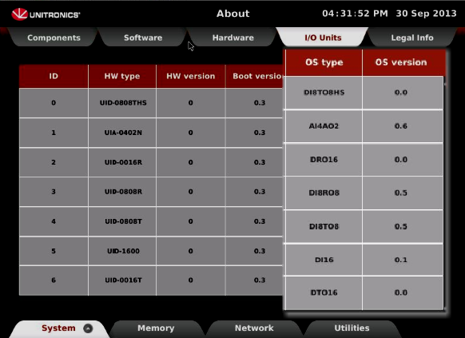 | 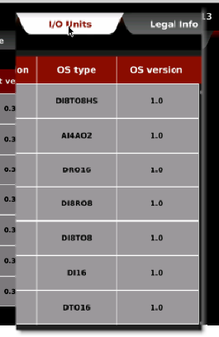

Upgrading requires four steps:
1. Upgrading the OS BIN file to 1.0.6
2. Downloading an empty UniLogic application—this application must NOT contain any I/O or COM modules in Hardware Configuration.
3. Upgrading the I/O OS versions to 1.0.
4. Upgrading the OS BIN file to 1.0.7.

- Please follow the instructions step-by-step.
- Please note that the I/O modules must be mounted on the panel, and may not be connected via local expansion cable.

Note: In order to perform the upgrade, you must use a disk-on-key (DOK).
This DOK must be:
- Formatted to FAT32
- Be empty of files
- Have a minimum capacity of 4G

Before you begin
Download the files UniStream_Files_1_0_6.rar and UniStream_Files_1_0_7.rar from:

ftp: unitronics.exavault.com
User: NG-proj
Password: UnitNGtest

Enter the directory Software and Tools > UniStream Ver_1.0.6 & Ver_1.0.7

Step 1. Upgrading UniStream Bin Files to 1.0.6

1. Unzip UniStream_Files_1_0_6.rar, and copy the entire folder ("UniStream_Files") to your DOK. This must be the only file on the DOK.
Do not copy UniStream_Files_1_0_7.rar at this time.
2. Enter UniApps: touch and maintain contact for several seconds with the upper right corner of the HMI Panel touchscreen until UniApps appears.
3. Connect the DOK to the USB port on the UniStream panel.
4. In UniApps, select System> Upgrades > Upgrade PLC and then press Upgrade BIN files.
5. Enter the password: 2468
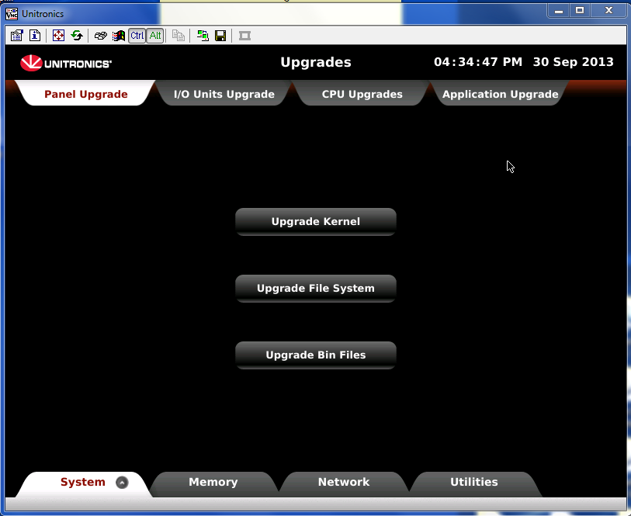

6. Press Upgrade; UniStream will briefly enter Stop Mode, and then will begin the upgrade process.
Note that the process may take several minutes, and will include a system reset.
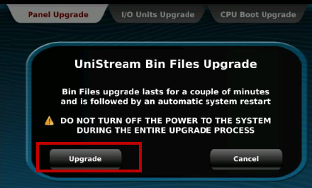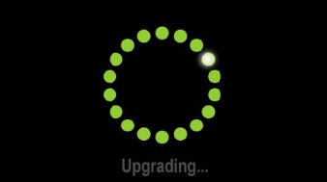

When the upgrade process is complete, the Panel will show the blank screen of the downloaded blank application.
7. Enter UniApps > About; to see that the BIN files have been upgraded to 1.0.6.

Step 2. Downloading a blank UniLogic application
This application must NOT contain any I/O or COM modules in Hardware Configuration.
When you download the blank application, you may receive the following error:
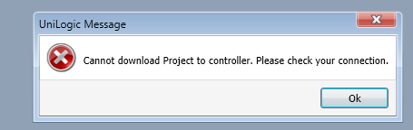

If this happens, wait for approximately 30 seconds; the application should begin downloading.
Note that, at the end of the process, you may need to restart the UniStream controller.

Step 3. Upgrading I/O Units
1. Enter UniApps, then select System>Upgrades> I/O Units Upgrade.
2. Press Upgrade all I/O units; upgrade begins.
3. Follow the on-screen directions.
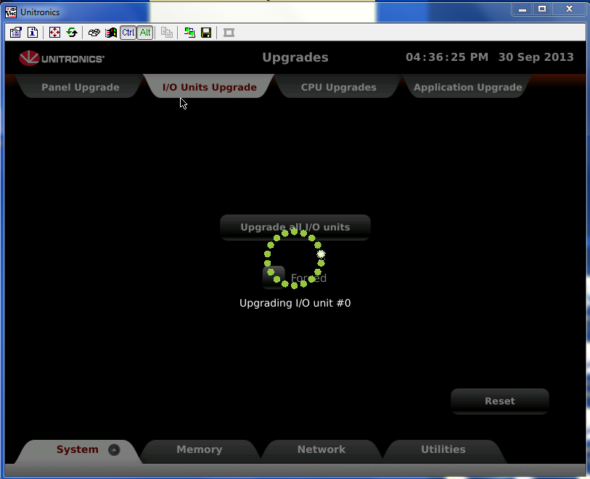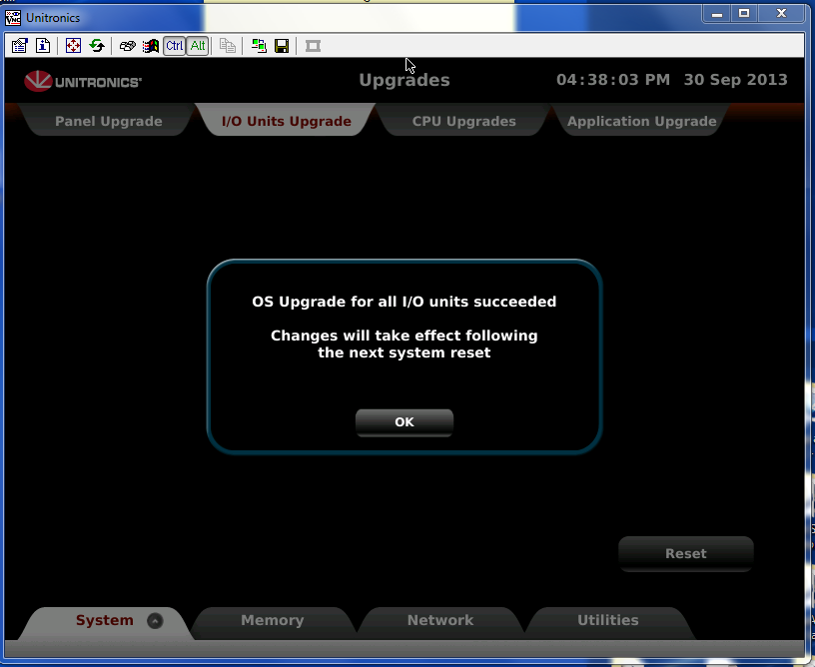
4. Reset the PLC.
5. Enter UniApps to check that the
I/O files have been upgraded to 1.0.

Step 4. Upgrading UniStream Bin Files to 1.0.7
1. Unzip UniStream_Files_1_0_7.rar, and copy the entire folder ("UniStream_Files") to your DOK. This must be the only file on the DOK.
2. Connect the DOK to the USB port on the UniStream panel.
3. In UniApps, select System> Upgrades > Upgrade PLC; and then press Upgrade BIN files.
4. Enter the password: 2468
5. Press Upgrade; UniStream will briefly enter Stop Mode, and then will begin the upgrade process.
Note that the process may take several minutes, and will include a system reset.

When the upgrade process is complete, the Panel will show the blank screen of the downloaded blank application.
6. Enter UniApps > About; to see that the BIN files have been upgraded to 1.0.7.

